NAME: PATEL JAY HITESHKUMAR

Roll No :20BCA86

Sem--IV

**1.Take User Input in The Textbox control and Print another textbox control**

**Code:**

Public Class Form1

Private Sub Button1_Click(sender As Object, e As EventArgs) Handles Btnsho.Click

TextBox2.Text = TextBox1.Text

End Sub

End Class

**Output:**

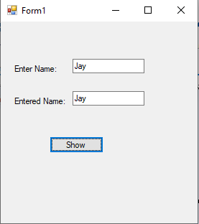

**2.Additon of Textbox Controls and print Ans in label control (Sum of Two Number).**

**Code:**

Public Class btnadd

Private Sub Button1_Click(sender As Object, e As EventArgs) Handles Button1.Click

lbladd.Text = Val(TextBox1.Text) + Val(TextBox2.Text)

End Sub

End Class

**Output:**

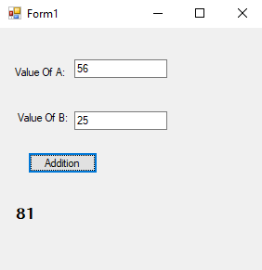

**3.Arithmatic Operators like Celsius to Fahrenheit, Rupee to dollar, pound,Euro.**

**Code:**

Public Class Form1

Private Sub Button1_Click(sender As Object, e As EventArgs) Handles Button1.Click

TextBox2.Text = Val((TextBox1.Text * 9 / 5)) + 32

End Sub

Private Sub Button2_Click(sender As Object, e As EventArgs) Handles Button2.Click

TextBox2.Text = Val(TextBox1.Text * 0.013)

End Sub

Private Sub Button3_Click(sender As Object, e As EventArgs) Handles Button3.Click

TextBox2.Text = Val(TextBox1.Text * 0.01)

End Sub

Private Sub Button4_Click(sender As Object, e As EventArgs) Handles Button4.Click

TextBox2.Text = Val(TextBox1.Text * 0.012)

End Sub

End Class

**Output:**

* Celsius to Fahrenheit

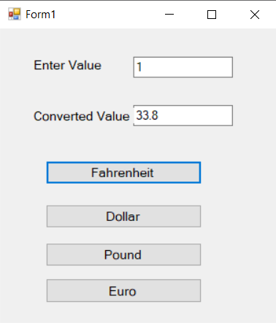

* Rupee to dollar

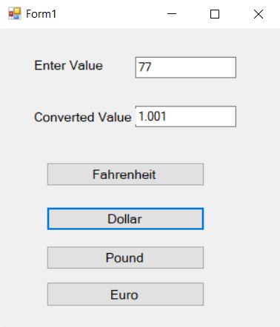

* Rupee to Pound

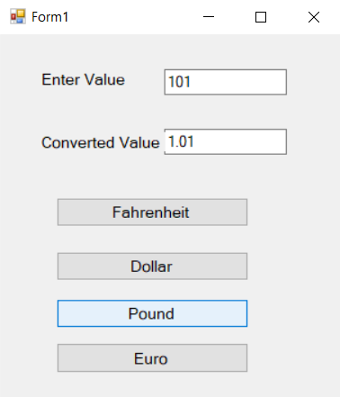

* Rupee to Euro

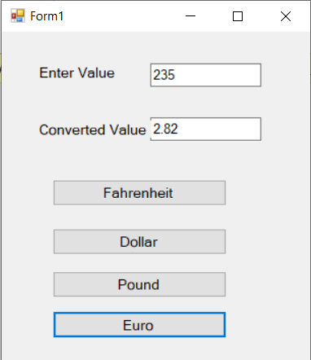

**3.Create simple calculator using 2 textboxes and 1 textbox for answer. Take 5 buttons for perform +,-, x, / and Clear the values.**

**Code:**

Public Class Form1

Private Sub Label1_Click(sender As Object, e As EventArgs) Handles Label1.Click

End Sub

Private Sub Btnsum_Click(sender As Object, e As EventArgs) Handles Btnsum.Click

TextBox3.Text = Val(TextBox1.Text) + Val(TextBox2.Text)

End Sub

Private Sub Btnsub_Click(sender As Object, e As EventArgs) Handles Btnsub.Click

TextBox3.Text = Val(TextBox1.Text) - Val(TextBox2.Text)

End Sub

Private Sub Btnmul_Click(sender As Object, e As EventArgs) Handles Btnmul.Click

TextBox3.Text = Val(TextBox1.Text) * Val(TextBox2.Text)

End Sub

Private Sub Btndiv_Click(sender As Object, e As EventArgs) Handles Btndiv.Click

TextBox3.Text = Val(TextBox1.Text) / Val(TextBox2.Text)

End Sub

Private Sub Btnclear_Click(sender As Object, e As EventArgs) Handles Btnclear.Click

TextBox1.Clear()

TextBox2.Clear()

TextBox3.Clear()

End Sub

End Class

Output:

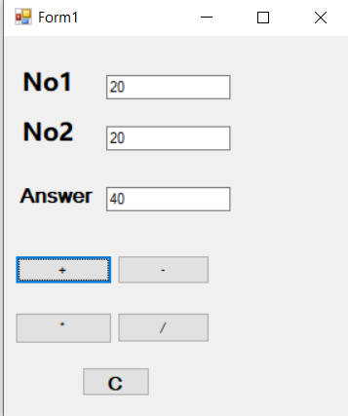

**5.Assignment**

**Code:**

Public Class Form1

Private Sub Form1_Load(sender As Object, e As EventArgs) Handles MyBase.Load

End Sub

Private Sub Button1_Click(sender As Object, e As EventArgs) Handles btnans.Click

'Assignment Operator

Dim a As Integer

a = 10

a += 5

' a -= 4

' a *= 5

' a /= 2

' a ^= 4

TextBox1.Text = a

End Sub

End Class

**Output:**

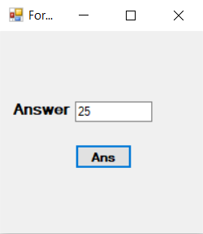

**6.Relational/Comparison**

**Code:**

Public Class Form1

Private Sub Form1_Load(sender As Object, e As EventArgs) Handles MyBase.Load

End Sub

Private Sub Button1_Click(sender As Object, e As EventArgs) Handles btnans.Click

Dim n1 As Integer = 10

If n1 = 20 Then

'If n1 <> 20 Then

'If n1 <= 20 Then

'If n1 >= 20 Then

TextBox1.Text = "Number Is 20"

Else

TextBox1.Text = "Number Is Not 20"

End If

End Sub

End Class

**Output:**

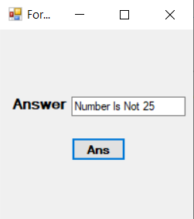

**7.Concatenation Operator**

**Code:**

Public Class Form1

Private Sub Form1_Load(sender As Object, e As EventArgs) Handles MyBase.Load

End Sub

Private Sub Button1_Click(sender As Object, e As EventArgs) Handles btnans.Click

Dim str1, str2 As String

str1 = "Jay"

str2 = "Patel"

TextBox1.Text = str1 + str2

End Sub

End Class

**Output:**

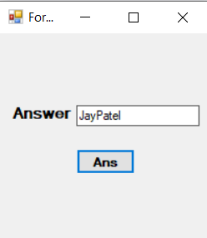

**8.Like Operator**

**Code:**

Public Class Form1

Private Sub Form1_Load(sender As Object, e As EventArgs) Handles MyBase.Load

End Sub

Private Sub Button1_Click(sender As Object, e As EventArgs) Handles btnans.Click

Dim a As String

a = "j" Like "J"

TextBox1.Text = a

End Sub

End Class

**Output:**

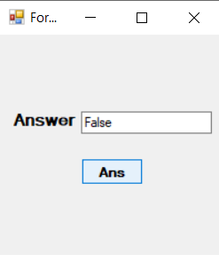

**9.** **The number is Numeric or not Demo. (If Else block)**

**Code:**

Public Class Form1

Private Sub Button1_Click(sender As Object, e As EventArgs) Handles Button1.Click

If IsNumeric(TextBox1.Text) Then

lblans.Text = "Data Is Numeric"

Else

lblans.Text = "Data Is Not Numeric"

End If

End Sub

End Class

**Output:**

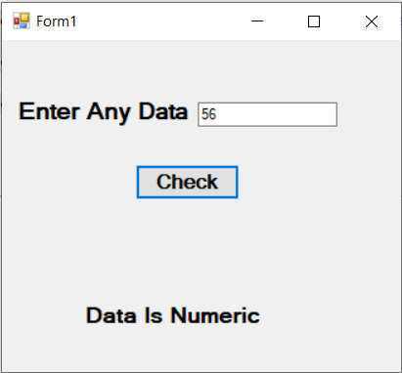

**10. Enter age and display category (Like Sr. or Gr.KG, Secondary, Primary, Higher)**

**Code:**

Public Class Form1

Private Sub Button1_Click(sender As Object, e As EventArgs) Handles Button1.Click

Dim age As Integer = TextBox1.Text

Select Case age

Case 1, 2

lblans.Text = "Child"

Case 3, 4

lblans.Text = "You Are In Sr.or Gr.KG"

Case 5 To 12

lblans.Text = "You Are In Primary Section"

Case 13 To 15

lblans.Text = "You Are In Secondary Section"

Case 16 To 18

lblans.Text = "You Are In Higher Secondary"

Case Else

lblans.Text = "No idea"

End Select

End Sub

End Class

**Output:**

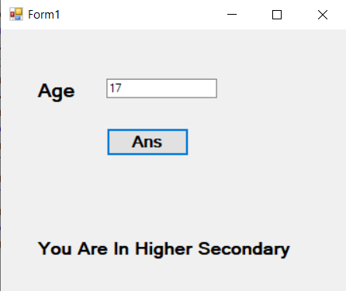

**11.Write an Application of find the number is odd or even.**

**Code:**

Public Class Form1

Private Sub chknum_Click(sender As Object, e As EventArgs) Handles chknum.Click

Dim n As Integer

n = TextBox1.Text

If TextBox1.Text Mod 2 = 0 Then

chkans.Text = ("Even Number Is " & n)

Else

chkans.Text = ("Odd Number Is " & n)

End If

End Sub

Private Sub clrtxt_Click(sender As Object, e As EventArgs) Handles clrtxt.Click

chkans.Text = ""

TextBox1.Clear()

End Sub

End Class

**Output:**

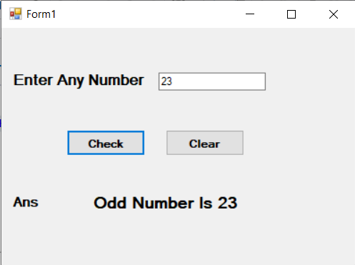

**12.DateTimePicker and selected date should be display in label.**

**Code:**

Public Class Form1

Private Sub Button1_Click(sender As Object, e As EventArgs) Handles Button1.Click

lbldate.Text = DateTimePicker1.Value.Date

End Sub

End Class

**Output:**

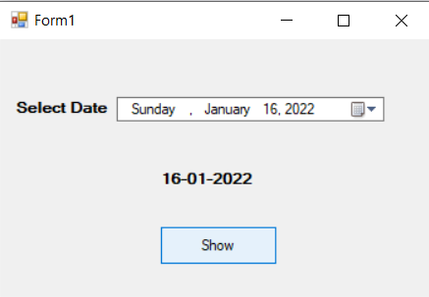

**13.Enter the number and prints its 1 to N. (input one text box print n number other textbox) and in textbox enter only digit.**

**Code:**

Public Class Form1

Private Sub Button1_Click_1(sender As Object, e As EventArgs) Handles btnN.Click

Dim i As Integer

For i = 1 To TextBox1.Text

TextBox2.Text &= i & Space(2)

Next

End Sub

Private Sub TextBox1_KeyPress(sender As Object, e As KeyPressEventArgs) Handles TextBox1.KeyPress

e.Handled = Not Char.IsDigit(e.KeyChar)

End Sub

End Class

**Output:**

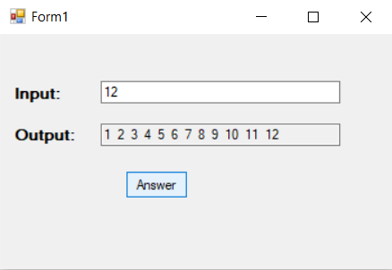

**14.** **Make a Table (5*5=25)**

**Code:**

Public Class Form1

Private Sub Button1_Click(sender As Object, e As EventArgs) Handles Button1.Click

Dim n1, n2, i As Integer

n1 = 5

n2 = 10

For i = 1 To n2

Dim a As Integer

a = n1 * i

lbltable.Text = lbltable.Text & n1 & " * " & i & " = " & a

lbltable.Text = lbltable.Text & vbCrLf

Next

End Sub

End Class

**Output:**

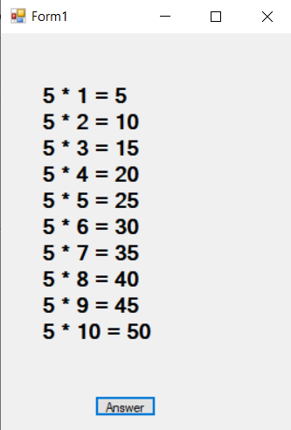

**15.** **Find 1 to 5 Factorial & ans is display in listbox and listbox type combobox.**

**Code:**

Public Class Form1

Public Function factorial(ByVal number As Integer) As Integer

Dim ans As Integer = 2

If number = 0 Or number = 1 Then ans = 1

If number < 0 Or number > 12 Then

Return -9999

End If

If number > 2 Then

For index As Integer = 3 To number

ans = ans * index

Next

End If

Return ans

End Function

Private Sub Button1_Click(sender As Object, e As EventArgs) Handles Button1.Click

ListBox1.Items.Clear()

For index As Integer = 1 To 5

ListBox1.Items.Add("Factorial of " & index.ToString & " Is = " & factorial(index).ToString)

Next

End Sub

End Class

**Output:**

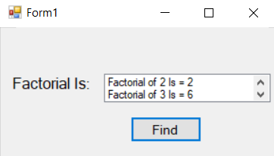

**16.Count number of Textboxes on form.**

**Code:**

Public Class Form1

Private Sub btncount_Click(sender As Object, e As EventArgs) Handles btncount.Click

Dim ctl As New Control

Dim cnt As Integer

For Each ctl In Me.Controls

If TypeOf ctl Is Windows.Forms.TextBox Then

cnt = cnt + 1

End If

Next

Label1.Text = cnt

End Sub

End Class

**Output:**

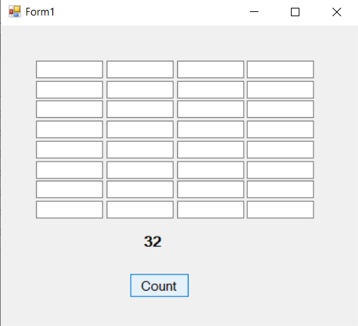

**17.** **Example of MsgBox and MassageBox.show.**

**Code:**

Public Class Form1

Private Sub Form1_Load(sender As Object, e As EventArgs) Handles MyBase.Load

MessageBox.Show("Welcome", "Hello", MessageBoxButtons.OKCancel, MessageBoxIcon.Error, MessageBoxDefaultButton.Button1)

End Sub

End Class

**Output:**

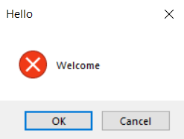

**18. Accept the name from Input Box and Display name in the message box.**

**Code:**

Public Class Form1

Private Sub Form1_Load(sender As Object, e As EventArgs) Handles MyBase.Load

' MessageBox.Show("Welcome", "Hello", MessageBoxButtons.OKCancel, MessageBoxIcon.Error, MessageBoxDefaultButton.Button1)

Dim a As String

a = InputBox("Enter Your Name:", "Demo")

MessageBox.Show(a)

End Sub

End Class

**Output:**

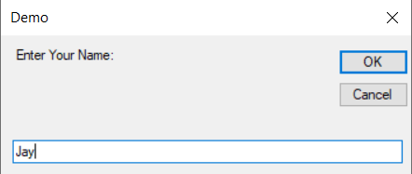

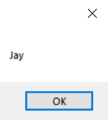

**19. Function procedures (Demo)**

**Code:**

Public Class Form1

Private Sub btnans_Click(sender As Object, e As EventArgs) Handles btnans.Click

txtsqr.Text = sqr(txtinput.Text)

txtcub.Text = cube(txtinput.Text)

End Sub

Function sqr(ByVal no As Integer) As Integer

Return no * no

End Function

Function cube(ByVal no As Integer) As Integer

Return no * no * no

End Function

End Class

**Output:**

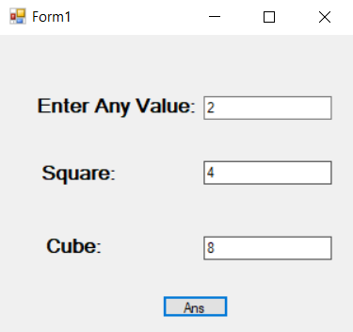

**20. Swapping of 2 values**

**Code:**

Public Class Form1

Private Sub Button1_Click(sender As Object, e As EventArgs) Handles btnswp.Click

Dim x, y As Integer

x = TextBox1.Text

y = TextBox2.Text

swap(x, y)

TextBox3.Text = x

TextBox4.Text = y

End Sub

Sub swap(ByRef a As Integer, ByRef b As Integer)

Dim temp As Integer

temp = a

a = b

b = temp

End Sub

End Class

**Output:**

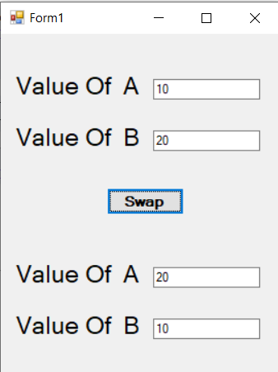

**21. Function Overloading**

**Code:**

Module Module1

Public Class calc

Public Sub sum(ByVal a As Integer, ByVal b As Integer)

System.Console.WriteLine("a + b = {0}", a + b)

End Sub

Public Sub sum(ByVal a As Integer, ByVal b As Integer, ByVal c As Integer)

System.Console.WriteLine("a + b + c = {0}", a + b + c)

End Sub

End Class

Sub main(ByVal args As String())

Dim c As calc = New calc

c.sum(3, 3)

c.sum(3, 3, 3)

System.Console.WriteLine("Press Enter to Exit....")

System.Console.ReadLine()

End Sub

End Module

**Output:**

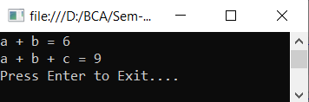

**22. Only character enter in the textbox otherwise print appropriate message.**

**Code:**

Public Class Form1

Private Sub tbdata_KeyPress(sender As Object, e As KeyPressEventArgs) Handles tbdata.KeyPress

If Asc(e.KeyChar) < 65 Or Asc(e.KeyChar) > 90 And Asc(e.KeyChar) < 97 Or Asc(e.KeyChar) > 122 Then

e.Handled = True

MessageBox.Show("Enter Only Charcaters")

End If

End Sub

End Class

**Output:**

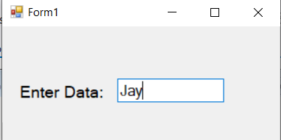

**23. Create simple calculator using the concept of sender.**

**Code:**

Public Class Form1

Dim no1 As Double

Dim op As Char

Private Sub btn0_Click(ByVal sender As Object, e As EventArgs) Handles btn0.Click, btn00.Click, btn1.Click, btn2.Click, btn3.Click, btn4.Click, btn5.Click, btn6.Click, btn7.Click, btn8.Click, btn9.Click

txtcalval.Text = sender.text

End Sub

Private Sub btndiv_Click(sender As Object, e As EventArgs) Handles btndiv.Click, btnsub.Click, btnsum.Click, btnmul.Click

no1 = txtcalval.Text

txtcalval.Clear()

op = sender.text

End Sub

Private Sub btnclear_Click(sender As Object, e As EventArgs) Handles btnclear.Click

txtcalval.Clear()

End Sub

Private Sub btneqal_Click(ByVal sender As Object, e As EventArgs) Handles btneqal.Click

If op = "+" Then

txtcalval.Text = no1 + Val(txtcalval.Text)

ElseIf op = "-" Then

txtcalval.Text = no1 - txtcalval.Text

ElseIf op = "X" Then

txtcalval.Text = no1 * txtcalval.Text

ElseIf op = "/" Then

txtcalval.Text = no1 / txtcalval.Text

End If

End Sub

End Class

**Output:** 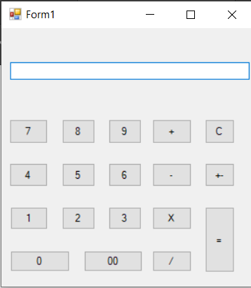

**24. Write a program to calculate number is Prime or not.**

**Code:**

Public Class Form1

Private Sub Button1_Click(sender As Object, e As EventArgs) Handles Button1.Click

Dim i As Integer

Dim n As Integer

n = TextBox1.Text

For i = 2 To n - 1

If n Mod i = 0 Then

lblans.Text = "Number Is Not Prime"

Exit Sub

End If

Next

lblans.Text = "Number Is Prime"

End Sub

End Class

**Output:**

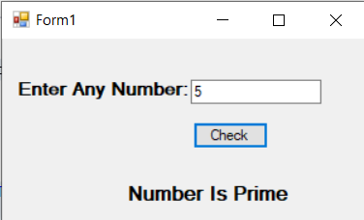

**25. String Class’s Properties and Method (Demo).**

**Code:**

Module Module1

Sub Main()

Dim str As String = "abc"

Dim ans As String

ans = str.Length()

System.Console.WriteLine(ans)

Dim ans1 As String

ans1 = String.Compare("JAY", "jay")

System.Console.WriteLine(ans1)

Dim ans3 As String

Dim str1 As String = "Jay"

Dim str2 As String = "Patel"

ans3 = String.Concat(str1, str2)

System.Console.WriteLine(ans3)

Dim ans4 As String

ans4 = String.Equals("ABC", "ABC")

System.Console.WriteLine(ans4)

Dim ans5 As String

ans5 = str.Insert(3, "def")

System.Console.WriteLine(ans5)

System.Console.ReadLine()

End Sub

End Module

**Output:**

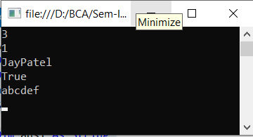

**26. Other inbuilt function (like Spit, join, Mid, Shell, Substr etc…)**

**Code:**

* **Split:**

Public Class Form1

Private Sub btnans_Click(sender As Object, e As EventArgs) Handles btnans.Click

Dim tempA() As String = Split(TextBox1.Text, (","))

TextBox2.text = tempA(0)

TextBox3.text = tempA(1)

TextBox4.text = tempA(2)

TextBox5.text = tempA(3)

End Sub

End Class

* **Join:**

Public Class Form1

Private Sub btnans_Click(sender As Object, e As EventArgs) Handles btnans.Click

Dim temp() As String = {"Bardoli", "Navsari", "Surat", "Bombay"}

TextBox1.Text = Join(temp, ",")

End Sub

End Class

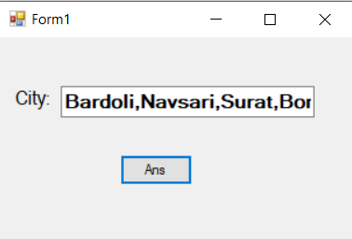

* **Mid:**

Public Class Form1

Private Sub btnans_Click(sender As Object, e As EventArgs) Handles btnans.Click

Dim Mystring, fword, lword, mword As String

Mystring = "Surat is Smart City"

fword = Mid(Mystring, 1, 3)

lword = Mid(Mystring, 10, 7)

mword = Mid(Mystring, 10)

MsgBox(lword)

End Sub

End Class

* **Shell:**

Public Class Form1

Private Sub btnans_Click(sender As Object, e As EventArgs) Handles btnans.Click

Dim open As Integer

open = Shell("C:\Program Files\Notepad++\notepad++.exe", AppWinStyle.NormalFocus)

End Sub

End Class

**27. Create login from and user name “SAI RAM” password=”123” then message will display login succefully otherwise access denied.**

**Code:**

Public Class Form1

Private Sub Login_Click(sender As Object, e As EventArgs) Handles Login.Click

If user.Text = "SAI RAM" And pass.Text = "123" Then

MsgBox("login Sucessfully")

Else

MsgBox("Access Denine")

End If

End Sub

End Class

**Output:**

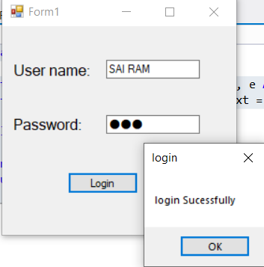

**28. Small Notepad.**

**Code:**

Public Class Form1

Private Sub btncut_Click(sender As Object, e As EventArgs) Handles btncut.Click

txtdata.Cut()

End Sub

Private Sub btncpy_Click(sender As Object, e As EventArgs) Handles btncpy.Click

txtdata.Copy()

End Sub

Private Sub btnpst_Click(sender As Object, e As EventArgs) Handles btnpst.Click

txtdata.Paste()

End Sub

Private Sub btnundo_Click(sender As Object, e As EventArgs) Handles btnundo.Click

txtdata.Undo()

End Sub

Private Sub btnredo_Click(sender As Object, e As EventArgs) Handles btnredo.Click

If txtdata.CanRedo = True Then

txtdata.Undo()

txtdata.ClearUndo()

End If

End Sub

Private Sub btnclr_Click(sender As Object, e As EventArgs) Handles btnclr.Click

txtdata.Clear()

End Sub

Private Sub upper_Click(sender As Object, e As EventArgs) Handles upper.Click

txtdata.Text = UCase(txtdata.Text)

End Sub

Private Sub Lower_Click(sender As Object, e As EventArgs) Handles Lower.Click

txtdata.Text = LCase(txtdata.Text)

End Sub

End Class

**Output:**

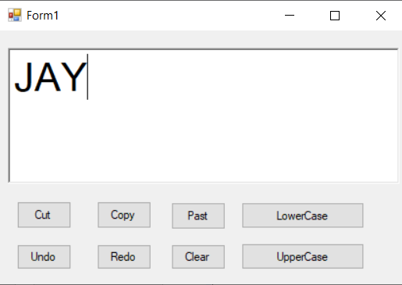

**29. Enter restricted data only (use of Error provider).**

**Code:**

Public Class Form1

Private Sub txtname_KeyPress(sender As Object, e As KeyPressEventArgs) Handles txtname.KeyPress

If Asc(e.KeyChar) >= 48 And Asc(e.KeyChar) <= 57 Then

e.Handled = True

ErrorProvider1.SetError(txtname, "Please Enter Only Name")

Else

e.Handled = False

End If

End Sub

Private Sub txtage_KeyPress(sender As Object, e As KeyPressEventArgs) Handles txtage.KeyPress

If Asc(e.KeyChar) >= 48 And Asc(e.KeyChar) <= 57 Or Asc(e.KeyChar) = 8 Then

e.Handled = False

Else

e.Handled = True

ErrorProvider1.SetError(txtage, "Please Enter Only Number")

End If

End Sub

End Class

**Output:**

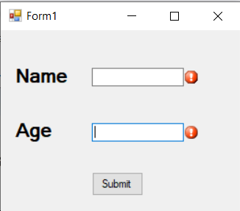

**30.** **Use of Radio Button Control**

**Code:**

Public Class Form1

Private Sub Answer_Click(sender As Object, e As EventArgs) Handles Answer.Click

Dim str As String

str = "Your Name is " & txtname.Text

If rdomale.Checked = True Then

str &= " Your Gender is Male"

Else

str &= "Your Gender is Female"

End If

MsgBox(str, MsgBoxStyle.Information, "Hello")

End Sub

End Class

**Output:**

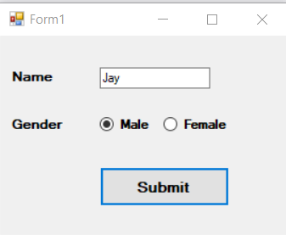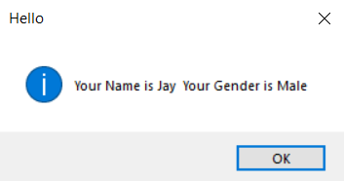

**31.** **Use of Radio Button Control**

**Code:**

Public Class Form1

Private Sub rdomale_CheckedChanged(sender As Object, e As EventArgs) Handles rdomale.CheckedChanged

PictureBox1.Image = Image.FromFile("D:\BCA\Sem-IV\VB.NET\Pro\male.jpg")

End Sub

Private Sub rdofemale_CheckedChanged(sender As Object, e As EventArgs) Handles rdofemale.CheckedChanged

PictureBox1.Image = Image.FromFile("D:\BCA\Sem-IV\VB.NET\Pro\female.jpg")

End Sub

End Class

**Output:**

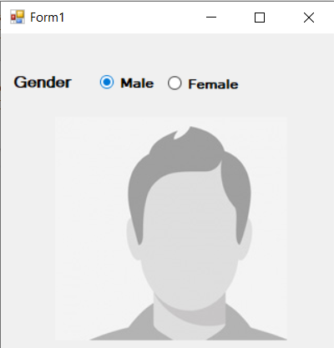

**32.** **Demo of Insert, Add, Remove methods**

**Code:**

Public Class Form1

Private Sub Add_Click(sender As Object, e As EventArgs) Handles Add.Click

lstname.Items.Add(txtname.Text)

txtname.Clear()

End Sub

Private Sub remove_Click(sender As Object, e As EventArgs) Handles remove.Click

If lstname.Items.Contains(txtname.Text) Then

lstname.Items.Remove(txtname.Text)

End If

txtname.Clear()

End Sub

Private Sub insert_Click(sender As Object, e As EventArgs) Handles insert.Click

lstname.Items.Insert(txtpos.Text, txtval.Text)

txtpos.Clear()

txtval.Clear()

End Sub

End Class

**Output:**

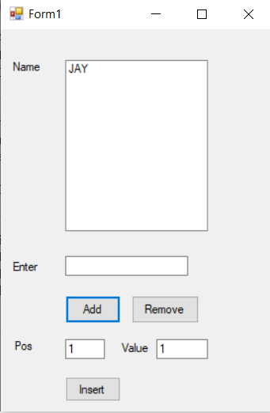

**33.** **Create following demo**

**Code:**

Public Class Form1

Private Sub rightshift_Click(sender As Object, e As EventArgs) Handles rightshift.Click

lstname1.Items.Add(lstname.SelectedItem)

lstname.Items.Remove(lstname.SelectedItem)

End Sub

Private Sub leftshift_Click(sender As Object, e As EventArgs) Handles leftshift.Click

lstname.Items.Add(lstname1.SelectedItem)

lstname1.Items.Remove(lstname1.SelectedItem)

End Sub

Private Sub allright_Click(sender As Object, e As EventArgs) Handles allright.Click

Dim i As Integer

For i = 0 To lstname1.Items.Count - 1

lstname.Items.Add(lstname1.Items.Item(i))

Next

lstname1.Items.Clear()

End Sub

Private Sub allLeft_Click(sender As Object, e As EventArgs) Handles allLeft.Click

Dim i As Integer

For i = 0 To lstname.Items.Count - 1

lstname1.Items.Add(lstname.Items.Item(i))

Next

lstname.Items.Clear()

End Sub

Private Sub shiftMright_Click(sender As Object, e As EventArgs) Handles shiftMright.Click

Dim i As Integer

For i = 0 To lstname1.SelectedItems.Count - 1

lstname.Items.Add(lstname1.SelectedItems.Item(0))

lstname1.Items.Remove(lstname1.SelectedItems.Item(0))

Next

End Sub

Private Sub shiftMleft_Click(sender As Object, e As EventArgs) Handles shiftMleft.Click

Dim i As Integer

For i = 0 To lstname.SelectedItems.Count - 1

lstname1.Items.Add(lstname.SelectedItems.Item(0))

lstname.Items.Add(lstname.SelectedItems.Item(0))

Next

End Sub

Private Sub Form1_Load(sender As Object, e As EventArgs) Handles MyBase.Load

lstname.Items.Add("Aku")

lstname.Items.Add("Janu")

lstname.Items.Add("Anchit")

lstname.Items.Add("Urja")

lstname.Items.Add("Neeti")

lstname1.Items.Add("Om")

lstname1.Items.Add("Sai")

lstname1.Items.Add("Ram")

lstname1.Items.Add("Jimi")

lstname1.Items.Add("Ami")

lstname1.Items.Add("Jay")

lstname1.Items.Add("Dev")

End Sub

End Class

**Output:**

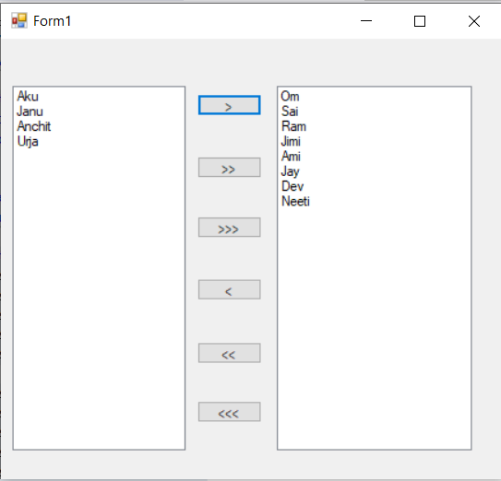

**34. Take input from the user in the Textbox for starting character and check all the List items whose starting character is that.**

**Code:**

Public Class Form1

Private Sub btnchk_Click(sender As Object, e As EventArgs) Handles btnchk.Click

Dim str As String

Dim i As Integer

For i = 0 To chklstname.Items.Count - 1

str = chklstname.Items.Item(i)

If str.StartsWith(txtname.Text) = True Then

chklstname.SetItemChecked(i, True)

Else

chklstname.SetItemChecked(i, False)

End If

Next

End Sub

Private Sub btnunchk_Click(sender As Object, e As EventArgs) Handles btnunchk.Click

Dim i As Integer

For i = 0 To chklstname.Items.Count - 1

chklstname.SetItemChecked(i, False)

Next

End Sub

Private Sub Form1_Load(sender As Object, e As EventArgs) Handles MyBase.Load

chklstname.Items.Add("Parth")

chklstname.Items.Add("Bhvik")

chklstname.Items.Add("Khushi")

chklstname.Items.Add("Catan")

chklstname.Items.Add("Divya")

chklstname.Items.Add("Jay")

chklstname.Items.Add("Keval")

chklstname.Items.Add("Hardik")

End Sub

End Class

**Output:**

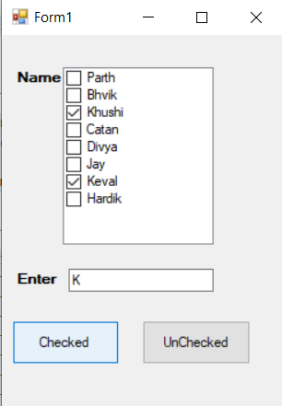

**35.Take 2 ComboBox set their name like cmbRollNo which contains number of the student, second one cmbName which contains names of the student. When we select rollno then student should display vice versa.**

**Code:**

Public Class Form1

Private Sub Form1_Load(sender As Object, e As EventArgs) Handles MyBase.Load

With cmbno.Items

.Add("1")

.Add("2")

.Add("3")

.Add("4")

.Add("5")

.Add("6")

End With

With cmbname.Items

.Add("Jay")

.Add("Parth")

.Add("Keval")

.Add("Khushi")

.Add("Mayur")

.Add("Vivek")

End With

End Sub

Private Sub cmbno_SelectedIndexChanged(sender As Object, e As EventArgs) Handles cmbno.SelectedIndexChanged

cmbname.SelectedIndex = cmbno.SelectedIndex

End Sub

Private Sub cmbname_SelectedIndexChanged(sender As Object, e As EventArgs) Handles cmbname.SelectedIndexChanged

cmbno.SelectedIndex = cmbname.SelectedIndex

End Sub

End Class

**Output:**

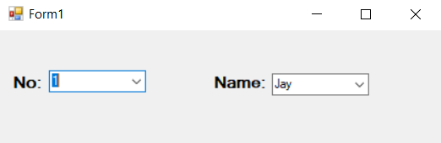

**36. Login page like following and Tooltip control**

**Code:**

Public Class Form1

Private Sub btnclos_Click(sender As Object, e As EventArgs) Handles btnclos.Click

Close()

End Sub

Private Sub TextBox1_MouseHover(sender As Object, e As EventArgs) Handles TextBox1.MouseHover

ToolTip1.SetToolTip(TextBox1, "Enter Username")

End Sub

Private Sub TextBox2_MouseHover(sender As Object, e As EventArgs) Handles TextBox2.MouseHover

ToolTip1.SetToolTip(TextBox2, "Enter Password")

End Sub

Private Sub btnclos_MouseHover(sender As Object, e As EventArgs) Handles btnclos.MouseHover

ToolTip1.SetToolTip(btnclos, "Close")

End Sub

End Class

**Output:**

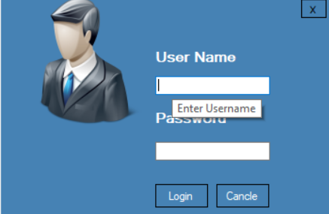

**37. Color Mixer using HorizonalScoll bar control**

**Code:**

Public Class Form1

Private Sub Hsred_Scroll(sender As Object, e As ScrollEventArgs) Handles Hsred.Scroll

PictureBox1.BackColor = Color.FromArgb(Hsred.Value, Hsgreen.Value, Hsblue.Value)

End Sub

Private Sub Hsgreen_Scroll(sender As Object, e As ScrollEventArgs) Handles Hsgreen.Scroll

PictureBox1.BackColor = Color.FromArgb(Hsred.Value, Hsgreen.Value, Hsblue.Value)

End Sub

Private Sub Hsblue_Scroll(sender As Object, e As ScrollEventArgs) Handles Hsblue.Scroll

PictureBox1.BackColor = Color.FromArgb(Hsred.Value, Hsgreen.Value, Hsblue.Value)

End Sub

End Class

**Output:**

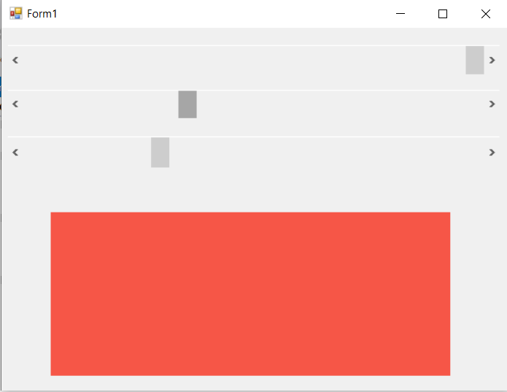

**38.Timer Demo.**

**Code:**

Public Class Form1

Dim i As Integer

Dim s(9) As Color

Dim left As Boolean

Private Sub Form1_Load(sender As Object, e As EventArgs) Handles MyBase.Load

s(0) = Color.DarkBlue

s(1) = Color.Gray

s(2) = Color.Khaki

s(3) = Color.OliveDrab

s(4) = Color.Violet

s(5) = Color.Chocolate

s(6) = Color.WhiteSmoke

s(7) = Color.Magenta

s(9) = Color.Bisque

End Sub

Private Sub Timer1_Tick(sender As Object, e As EventArgs) Handles Timer1.Tick

Label1.BackColor = s(i)

Label1.ForeColor = s(i + 1)

i = i + 1

If i = 8 Then

i = 0

End If

End Sub

Private Sub Label1_Click(sender As Object, e As EventArgs) Handles Label1.Click

If left = False Then

Label1.Left = Label1.Left + 50

If Label1.Left >= 700 Then

left = True

End If

ElseIf left = True Then

Label1.Left = Label1.Left - 50

If Label1.Left <= 10 Then

left = False

End If

End If

End Sub

Private Sub Button1_Click(sender As Object, e As EventArgs) Handles Button1.Click

Timer1.Start()

End Sub

Private Sub Button2_Click(sender As Object, e As EventArgs) Handles Button2.Click

Timer1.Stop()

End Sub

End Class

**Output:**

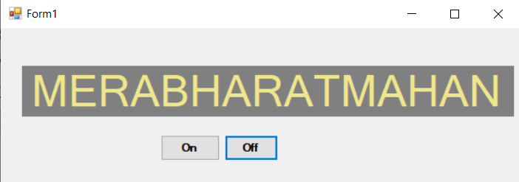

**39. Print the Table according to position of the Track Bar.**

**Code:**

Public Class Form1

Private Sub TrackBar1_Scroll(sender As Object, e As EventArgs) Handles TrackBar1.Scroll

tblans.Text = ""

Dim i As Integer

For i = 1 To 10

tblans.Text &= TrackBar1.Value & " X " & i & " = " & (TrackBar1.Value * i) & vbNewLine

Next

End Sub

End Class

**Output:**

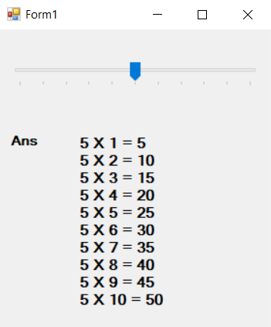

**40. Change the background**

**Code:**

Public Class Form1

Private Sub TrackBarRed_Scroll(sender As Object, e As EventArgs) Handles TrackBarRed.Scroll, TrackBarGreen.Scroll, TrackBarBlue.Scroll

Me.BackColor = Color.FromArgb(TrackBarRed.Value, TrackBarGreen.Value, TrackBarBlue.Value)

txtred.Text = TrackBarRed.Value

txtgreen.Text = TrackBarGreen.Value

txtblue.Text = TrackBarBlue.Value

End Sub

End Class

**Output:**

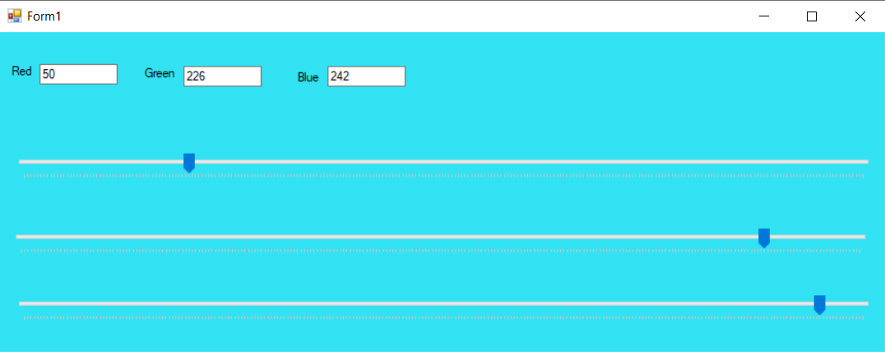

**41. Change background color of the from runtime and default set orange color as selected color in the color Dialog.**

**Code:**

Public Class Form1

Private Sub setcol_Click(sender As Object, e As EventArgs) Handles setcol.Click

With ColorDialog1

.Color = Color.Orange

If .ShowDialog() = Windows.Forms.DialogResult.OK Then

Me.BackColor = .Color

End If

End With

End Sub

End Class

**Output:**

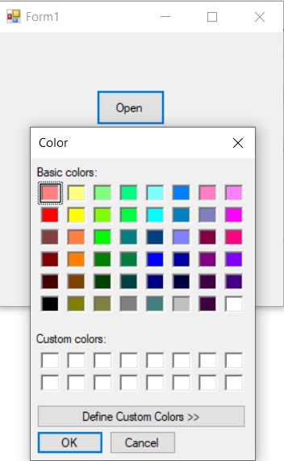

**42. Change the background color and foreground color (font color) of the Rich Textbox. You can click on back color then open color dilogbox that same font color then open font dilogbox and change in textbox contain.**

**Code:**

Public Class Form1

Private Sub bgcolor_Click(sender As Object, e As EventArgs) Handles bgcolor.Click

If ColorDialog1.ShowDialog = Windows.Forms.DialogResult.OK Then

RichTextBox1.BackColor = ColorDialog1.Color

End If

End Sub

Private Sub fontcolour_Click(sender As Object, e As EventArgs) Handles fontcolour.Click

If ColorDialog1.ShowDialog = Windows.Forms.DialogResult.OK Then

RichTextBox1.ForeColor = ColorDialog1.Color

End If

End Sub

Private Sub btnfont_Click(sender As Object, e As EventArgs) Handles btnfont.Click

If FontDialog1.ShowDialog = Windows.Forms.DialogResult.OK Then

RichTextBox1.Font = FontDialog1.Font

End If

End Sub

End Class

**Output:**

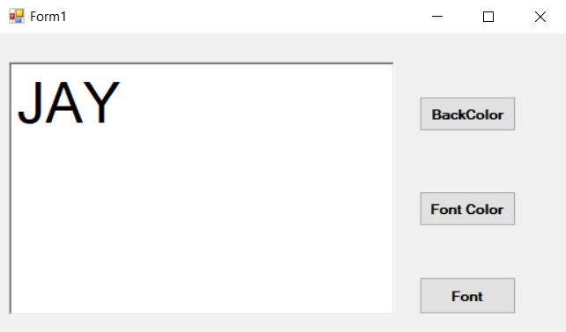

**43. Create WordPad with Menus**

**Code:**

Public Class Notepad

Private Sub NewToolStripMenuItem_Click(sender As Object, e As EventArgs) Handles NewToolStripMenuItem.Click

If Me.Text <> "Notepad" Then

RichTextBox1.SaveFile(Me.Text, RichTextBoxStreamType.PlainText)

MsgBox("Your File Save", MsgBoxStyle.Information, "Notepad")

Me.Text = "Notepad"

RichTextBox1.Clear()

Else

End If

End Sub

Private Sub OpenToolStripMenuItem_Click(sender As Object, e As EventArgs) Handles OpenToolStripMenuItem.Click

With OpenFileDialog1

.Filter = "Text file|*.text|All file(*.*)|*.*"

If .ShowDialog = Windows.Forms.DialogResult.OK Then

RichTextBox1.LoadFile(.FileName, RichTextBoxStreamType.PlainText)

Me.Text = .FileName

End If

End With

End Sub

Private Sub SaveToolStripMenuItem_Click(sender As Object, e As EventArgs) Handles SaveToolStripMenuItem.Click

If Me.Text = "Notepad" Then

With SaveFileDialog1

.Filter = "Text file|*.txt|All file(*.*)|*.*"

.Title = "Save file"

If ShowDialog() = Windows.Forms.DialogResult.OK Then

RichTextBox1.SaveFile(.FileName, RichTextBoxStreamType.PlainText)

Me.Text = .FileName

Else

RichTextBox1.SaveFile(Me.Text, RichTextBoxStreamType.PlainText)

MsgBox("Your File is Saved", MsgBoxStyle.Information, "Notepad")

End If

End With

End If

End Sub

Private Sub SaveAsToolStripMenuItem_Click(sender As Object, e As EventArgs) Handles SaveAsToolStripMenuItem.Click

With SaveFileDialog1

.Filter = "Text file|*.txt|All file(*.*)|*.*"

If .ShowDialog = Windows.Forms.DialogResult.OK Then

RichTextBox1.SaveFile(.FileName, RichTextBoxStreamType.PlainText)

Me.Text = .FileName

End If

End With

End Sub

Private Sub ExitToolStripMenuItem_Click(sender As Object, e As EventArgs) Handles ExitToolStripMenuItem.Click

End

End Sub

Private Sub UndoToolStripMenuItem_Click(sender As Object, e As EventArgs) Handles UndoToolStripMenuItem.Click

RichTextBox1.Undo()

End Sub

Private Sub RedoToolStripMenuItem_Click(sender As Object, e As EventArgs) Handles RedoToolStripMenuItem.Click

RichTextBox1.Redo()

End Sub

Private Sub CutToolStripMenuItem_Click(sender As Object, e As EventArgs) Handles CutToolStripMenuItem.Click

RichTextBox1.Cut()

End Sub

Private Sub CopyToolStripMenuItem_Click(sender As Object, e As EventArgs) Handles CopyToolStripMenuItem.Click

RichTextBox1.Copy()

End Sub

Private Sub PastToolStripMenuItem_Click(sender As Object, e As EventArgs) Handles PastToolStripMenuItem.Click

RichTextBox1.Paste()

End Sub

Private Sub SelectAllToolStripMenuItem_Click(sender As Object, e As EventArgs) Handles SelectAllToolStripMenuItem.Click

RichTextBox1.SelectAll()

End Sub

Private Sub SelectedToolStripMenuItem_Click(sender As Object, e As EventArgs) Handles SelectedToolStripMenuItem.Click

With FontDialog1

If .ShowDialog = Windows.Forms.DialogResult.OK Then

RichTextBox1.SelectionFont = .Font

End If

End With

End Sub

Private Sub AllToolStripMenuItem_Click(sender As Object, e As EventArgs) Handles AllToolStripMenuItem.Click

With FontDialog1

If .ShowDialog = Windows.Forms.DialogResult.OK Then

RichTextBox1.SelectionFont = .Font

End If

End With

End Sub

Private Sub SelectedToolStripMenuItem1_Click(sender As Object, e As EventArgs) Handles SelectedToolStripMenuItem1.Click

With ColorDialog1

If .ShowDialog = Windows.Forms.DialogResult.OK Then

RichTextBox1.SelectionColor = .Color

End If

End With

End Sub

Private Sub LeftToolStripMenuItem_Click(sender As Object, e As EventArgs) Handles LeftToolStripMenuItem.Click

RichTextBox1.SelectionAlignment = HorizontalAlignment.Left

End Sub

Private Sub CenterToolStripMenuItem_Click(sender As Object, e As EventArgs) Handles CenterToolStripMenuItem.Click

RichTextBox1.SelectionAlignment = HorizontalAlignment.Center

End Sub

Private Sub RightToolStripMenuItem_Click(sender As Object, e As EventArgs) Handles RightToolStripMenuItem.Click

RichTextBox1.SelectionAlignment = HorizontalAlignment.Right

End Sub

Private Sub BulletToolStripMenuItem_Click(sender As Object, e As EventArgs) Handles BulletToolStripMenuItem.Click

RichTextBox1.BulletIndent = 2

RichTextBox1.SelectionBullet = True

End Sub

Private Sub ToolStripMenuItem2_Click(sender As Object, e As EventArgs) Handles ToolStripMenuItem2.Click

RichTextBox1.ZoomFactor = 2

End Sub

Private Sub ToolStripMenuItem3_Click(sender As Object, e As EventArgs) Handles ToolStripMenuItem3.Click

RichTextBox1.ZoomFactor = 5

End Sub

Private Sub AboutToolStripMenuItem_Click(sender As Object, e As EventArgs)

Dim frm As New FrameStyle

'frm.showdialog()

End Sub

Private Sub Notepad_Load(sender As Object, e As EventArgs) Handles MyBase.Load

End Sub

Private Sub ToolStripMenuItem4_Click(sender As Object, e As EventArgs) Handles ToolStripMenuItem4.Click

RichTextBox1.ZoomFactor = 10

End Sub

Private Sub ToolStripMenuItem5_Click(sender As Object, e As EventArgs) Handles ToolStripMenuItem5.Click

RichTextBox1.ZoomFactor = 15

End Sub

End Class

**Output:**

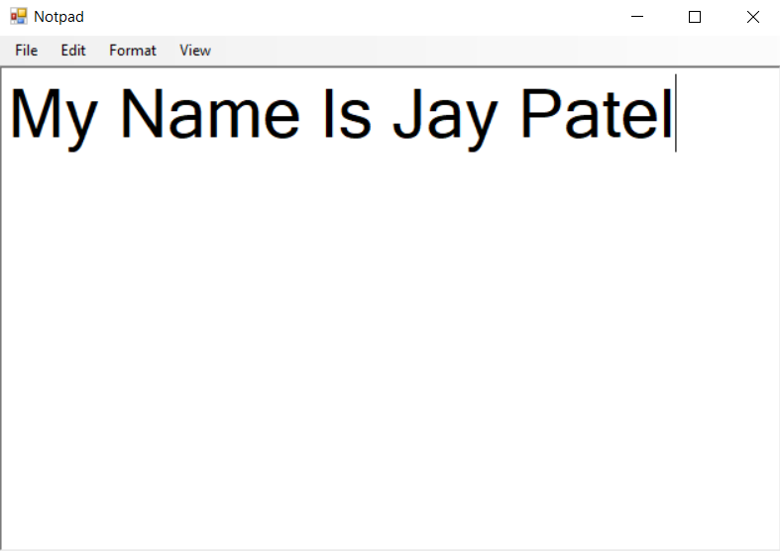

**44. Process Bar Demo using start and stop button.**

**Code:**

Public Class Form1

Private Sub Timer1_Tick(ByVal sender As System.Object, ByVal e As System.EventArgs) Handles Timer1.Tick

If ProgressBar1.Value >= ProgressBar1.Maximum Then

ProgressBar1.Value = 0

lblprocess.Text = ProgressBar1.Value

Else

ProgressBar1.Value += 20

End If

lblprocess.Text = ProgressBar1.Value

lblprocess.Text = "ProgressBar Value: " & lblprocess.Text

End Sub

Private Sub btnstart_Click(ByVal sender As System.Object, ByVal e As System.EventArgs) Handles btnstart.Click

Timer1.Start()

If btnstart.Text = "Continue" Then

btnstart.Text = "Start"

End If

End Sub

Private Sub btnstop_Click(ByVal sender As System.Object, ByVal e As System.EventArgs) Handles btnstop.Click

Timer1.Stop()

btnstart.Text = "Continue"

End Sub

End Class

**Output:**

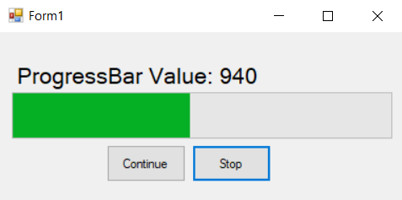

**45. TreeView Demo and List view Demo using TabControl.**

**Code:**

Public Class Form1

Private Sub btnans_Click(sender As Object, e As EventArgs) Handles btnans.Click

Dim node As New TreeNode

node = TreeView1.Nodes.Item(1)

MsgBox(node.Text)

End Sub

Private Sub Form1_Load(sender As Object, e As EventArgs) Handles MyBase.Load

ListView1.View = View.Details

ListView1.Columns.Add("Director", 70, HorizontalAlignment.Left)

ListView1.Columns.Add("Movie", 60, HorizontalAlignment.Left)

'ListView1.Columns.Add("Review", 40, HorizontalAlignment.Left)

ListView1.Items.Add("Yash C.")

ListView1.Items.Add("Sanjay B.")

ListView1.Items.Add("Rakesh R.")

ListView1.Items(0).SubItems.Add("Lamhe")

ListView1.Items(1).SubItems.Add("Devdas")

ListView1.Items(2).SubItems.Add("Krish")

End Sub

End Class

**Output:**

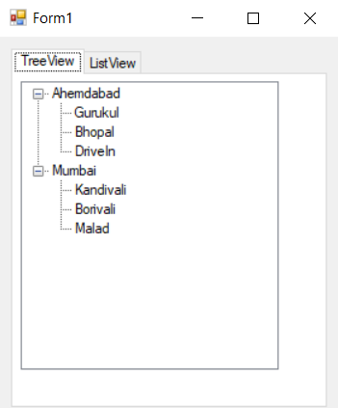

**46. Database store in the list box and combobox (Using Entity class and Database Class and also use with array and ArrayList) & use MastTextBox in date of join.**

**Code:**

Public Class Form1

Public Class EmployeeEntity

Public eid As Integer

Public ename As String

Public edoj As DateTime

End Class

Private Sub btnsave_Click(sender As Object, e As EventArgs) Handles btnsave.Click

Dim obj As New EmployeeEntity

obj.eid = txtid.Text

obj.ename = txtname.Text

obj.edoj = Convert.ToDateTime(txtdoj.Text)

ListBox1.Items.Add(obj.eid & "--" & obj.ename & "--" & obj.edoj)

txtid.Clear()

txtname.Clear()

txtdoj.Clear()

End Sub

Private Sub btndisplay_Click(sender As Object, e As EventArgs) Handles btndisplay.Click

ComboBox1.Items.Add(ListBox1.Items(0))

ComboBox1.Items.Add(ListBox1.Items(1))

ComboBox1.Items.Add(ListBox1.Items(2))

ComboBox1.Items.Add(ListBox1.Items(3))

ComboBox1.Items.Add(ListBox1.Items(4))

End Sub

End Class

**Output:**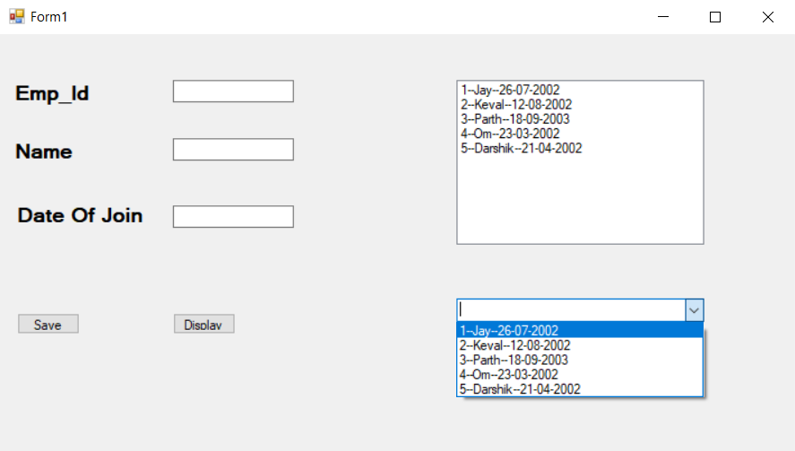

**47. Create VB.Net application that maintains information of students in the following data tables. Perform insert, update and delete operations and also generate report in DataGrid view for students who are studying in course BCA.**

**Code:**

Imports System.Data.OleDb

Public Class Form1

Dim cn As OleDbConnection

Dim cmd As OleDbCommand

Dim da As OleDbDataAdapter

Dim dt As DataTable

Dim ds As DataSet

Dim source As New BindingSource

Private Sub Form1_Load(sender As Object, e As EventArgs) Handles MyBase.Load

cn = New OleDbConnection("Provider=Microsoft.ACE.OLEDB.12.0;Data Source=D:\BCA\Sem-IV\VB.NET\Pro\students.accdb")

cn.Open()

MsgBox("DATABASE IS CONNECTED")

cn.Close()

End Sub

Private Sub btninsert_Click(sender As Object, e As EventArgs) Handles btninsert.Click

cmd = New OleDbCommand("Insert into studinfo values(' " & txtid.Text & " ',' " & txtname.Text & " ','" & txtcity.Text & " ',' " & txtcourse.Text & " ','" & txtdob.Text & " ',' " & txtadd.Text & "' )", cn)

cn.Open()

cmd.ExecuteNonQuery()

cn.Close()

MsgBox("RECORD INSERTED SUCCESSFULLY!")

clear()

End Sub

Sub clear()

txtid.Clear()

txtname.Clear()

txtcity.Clear()

txtcourse.Clear()

txtdob.Clear()

txtadd.Clear()

End Sub

Private Sub btnupdate_Click(sender As Object, e As EventArgs) Handles btnupdate.Click

cmd = New OleDbCommand("update studinfo set NAME ='" & txtname.Text & "',CITY= '" & txtcity.Text & "',COURSE=' " & txtcourse.Text & " ',DOB=' " & txtdob.Text & " ', ADDRESS= ' " & txtadd.Text & " ' where ID=" & txtid.Text & "", cn)

cn.Open()

cmd.ExecuteNonQuery()

cn.Close()

MsgBox("RECORD UPDATED SUCCESSFULLY")

clear()

End Sub

Private Sub btnnew_Click(sender As Object, e As EventArgs) Handles btnnew.Click

clear()

End Sub

Private Sub btnsearch_Click(sender As Object, e As EventArgs) Handles btnsearch.Click

da = New OleDbDataAdapter

dt = New DataTable

cmd = New OleDbCommand("select*from studinfo where ID=" & txtid.Text & "", cn)

cn.Open()

da.SelectCommand = cmd

da.Fill(dt)

cn.Close()

txtid.Text = dt.Rows(0).Item(0)

txtname.Text = dt.Rows(0).Item(1)

txtcity.Text = dt.Rows(0).Item(2)

txtcourse.Text = dt.Rows(0).Item(3)

txtdob.Text = dt.Rows(0).Item(4)

txtadd.Text = dt.Rows(0).Item(5)

End Sub

Private Sub btndelete_Click(sender As Object, e As EventArgs) Handles btndelete.Click

cmd = New OleDbCommand("delete from studinfo where id=" & txtid.Text & " ", cn)

cn.Open()

cmd.ExecuteNonQuery()

cn.Close()

MsgBox("RECORD DELETED SUCCESSFULLY")

clear()

End Sub

Private Sub btnview_Click(sender As Object, e As EventArgs) Handles btnview.Click

cn = New OleDbConnection("Provider=Microsoft.ACE.OLEDB.12.0;Data Source=D:\BCA\Sem-IV\VB.NET\Pro\students.accdb")

ds = New DataSet

Dim tables As DataTableCollection

tables = ds.Tables

da = New OleDbDataAdapter("Select* from studinfo where course=’BCA’", cn)

da.Fill(ds, "studinfo")

Dim view As New DataView(tables(0))

source.DataSource = view

DataGridView1.DataSource = view

End Sub

Private Sub DataGridView1_CellClick(sender As Object, e As DataGridViewCellEventArgs) Handles DataGridView1.CellClick

txtid.Text = DataGridView1.CurrentRow.Cells(0).Value.ToString()

txtname.Text = DataGridView1.CurrentRow.Cells(1).Value.ToString()

txtcity.Text = DataGridView1.CurrentRow.Cells(2).Value.ToString()

txtcourse.Text = DataGridView1.CurrentRow.Cells(3).Value.ToString()

txtdob.Text = DataGridView1.CurrentRow.Cells(4).Value.ToString()

txtadd.Text = DataGridView1.CurrentRow.Cells(5).Value.ToString()

End Sub

End Class

**Output:**

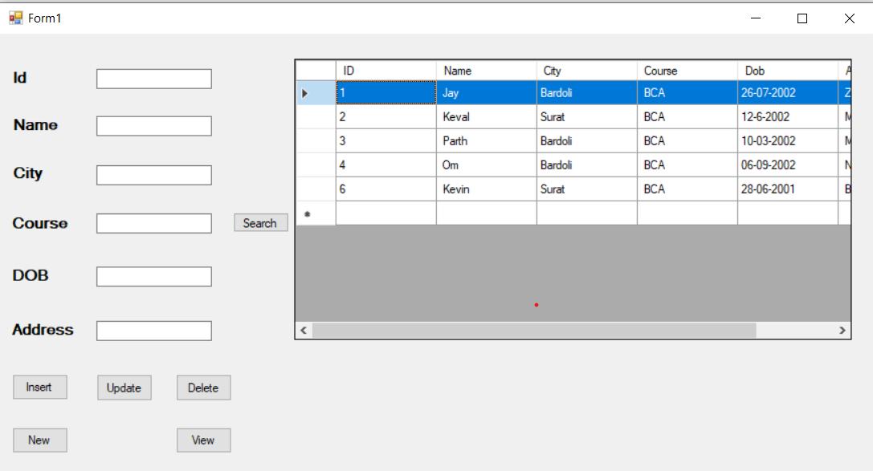

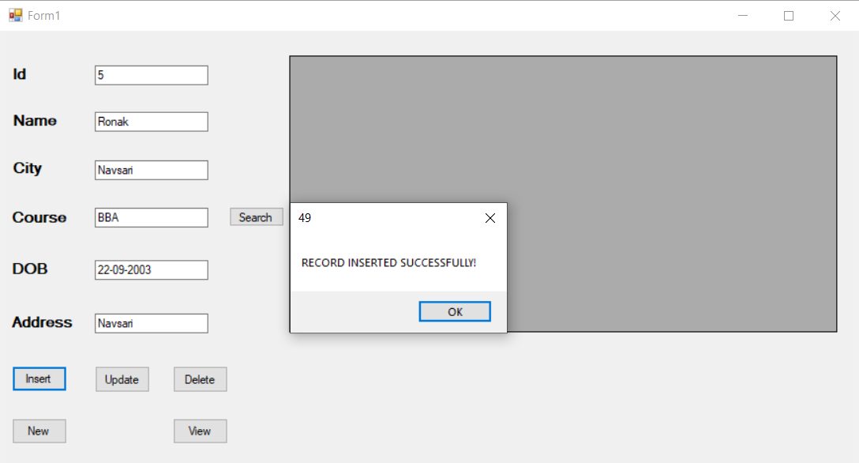

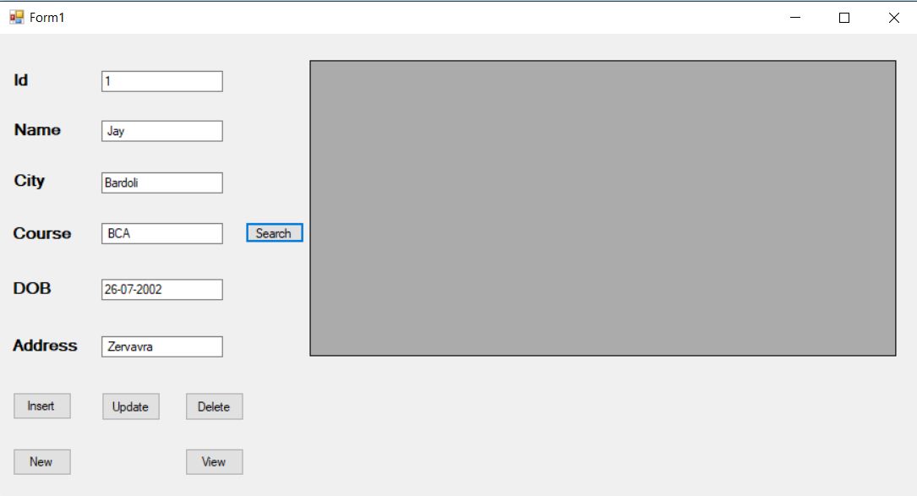

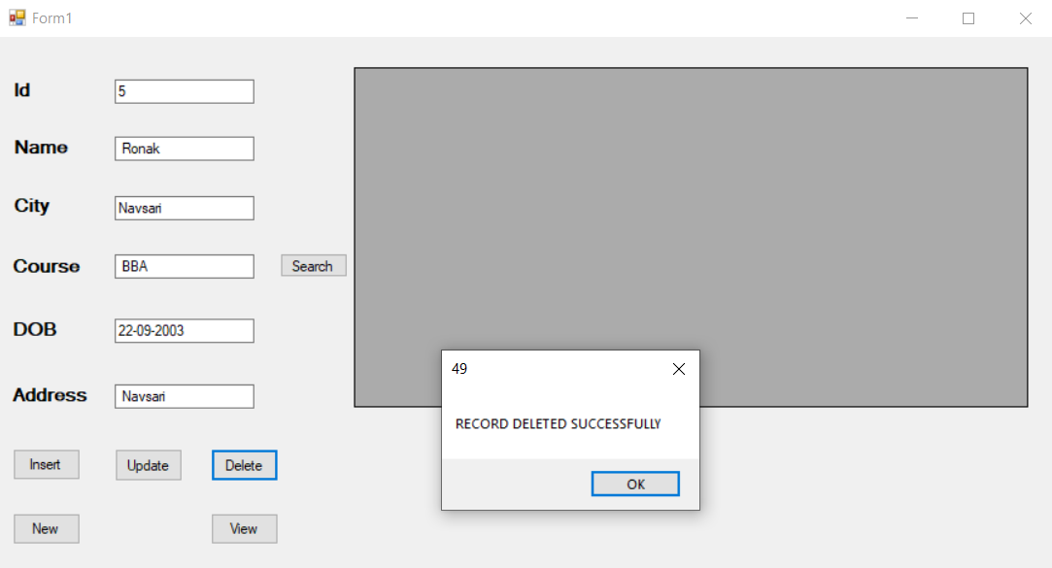

**48.Create vb.net application to maintain item information item_master itemNo,Name,Cost,Qty,Item type.Perform insert and delete operation and design proper from which such a particular item if it is found accepts new cost and qty.Also generate report of out of stock in datagridview**

**Code:**

Imports System.Data.OleDb

Public Class Form1

Dim cn As OleDbConnection

Dim cmd As OleDbCommand

Dim da As OleDbDataAdapter

Dim dt As DataTable

Dim ds As DataSet

Dim source As BindingSource

Private Sub Form1_Load(sender As Object, e As EventArgs) Handles MyBase.Load

cn = New OleDbConnection("Provider=Microsoft.ACE.OLEDB.12.0;Data Source=D:\BCA\Sem-IV\VB.NET\Pro\item.accdb")

cn.Open()

MsgBox("DATABASE CONNECTED")

cn.Close()

End Sub

Private Sub btninsert_Click(sender As Object, e As EventArgs) Handles btninsert.Click

cmd = New OleDbCommand("insert into item_mst values('" & txtid.Text & "','" & txtname.Text & "','" & txtcost.Text & "','" & txtqty.Text & "', '" & txtitemtype.Text & " ')", cn)

cn.Open()

cmd.ExecuteNonQuery()

cn.Close()

MsgBox("record inserted successfully")

Clear()

End Sub

Sub clear()

txtid.Clear()

txtname.Clear()

txtcost.Clear()

txtqty.Clear()

txtitemtype.Clear()

End Sub

Private Sub btnnew_Click(sender As Object, e As EventArgs) Handles btnnew.Click

clear()

End Sub

Private Sub btnupdate_Click(sender As Object, e As EventArgs) Handles btnupdate.Click

cmd = New OleDbCommand("update item_mst set NAME= '" & txtname.Text & "', COST='" & txtcost.Text & "' ,QUANTITY= '" & txtqty.Text & "' ,TYPE= '" & txtitemtype.Text & "'where ID=" & txtid.Text & " ", cn)

cn.Open()

cmd.ExecuteNonQuery()

cn.Close()

MsgBox("RECORD UPDATED SUCCESSFULLY")

End Sub

Private Sub btnsearch_Click(sender As Object, e As EventArgs) Handles btnsearch.Click

da = New OleDbDataAdapter

dt = New DataTable

cmd = New OleDbCommand("select * from item_mst where ID=" & txtid.Text & " ", cn)

cn.Open()

da.SelectCommand = cmd

da.Fill(dt)

cn.Close()

txtid.Text = dt.Rows(0).Item(0)

txtname.Text = dt.Rows(0).Item(1)

txtcost.Text = dt.Rows(0).Item(2)

txtqty.Text = dt.Rows(0).Item(3)

txtitemtype.Text = dt.Rows(0).Item(4)

End Sub

Private Sub btndelete_Click(sender As Object, e As EventArgs) Handles btndelete.Click

cmd = New OleDbCommand("delete from item_mst where ID=" & txtid.Text & "", cn)

cn.Open()

cmd.ExecuteNonQuery()

cn.Close()

MsgBox("RECORD DELETED SUCCESSFULLY")

clear()

End Sub

Private Sub btnview_Click(sender As Object, e As EventArgs) Handles btnview.Click

cn = New OleDbConnection("Provider=Microsoft.ACE.OLEDB.12.0;Data Source=D:\BCA\Sem-IV\VB.NET\Pro\item.accdb")

ds = New DataSet

da = New OleDbDataAdapter

Dim tables As DataTableCollection

tables = ds.Tables

cmd = New OleDbCommand("select * from item_mst where Quantity=0", cn)

cn.Open()

da.SelectCommand = cmd

da.Fill(ds, "item_mst")

Dim view1 As New DataView(tables(0))

DataGridView1.DataSource = view1

End Sub

Private Sub DataGridView1_CellContentClick(sender As Object, e As DataGridViewCellEventArgs) Handles DataGridView1.CellContentClick

txtid.Text = DataGridView1.CurrentRow.Cells(0).Value.ToString()

txtname.Text = DataGridView1.CurrentRow.Cells(2).Value.ToString()

txtcost.Text = DataGridView1.CurrentRow.Cells(3).Value.ToString()

txtqty.Text = DataGridView1.CurrentRow.Cells(4).Value.ToString()

txtitemtype.Text = DataGridView1.CurrentRow.Cells(5).Value.ToString()

End Sub

End Class

**Output:**

